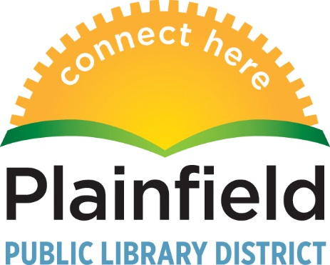
15025 S. Illinois Street
Plainfield IL 60544
www.plainfieldpubliclibrary.org

For Immediate Release
Wednesday, January 11, 2017
For More Information
Lisa Pappas, Interim Library Director
815-439-2874 or e-mail lpappas@plainfieldpubliclibrary.org

Plainfield Public Library District Board Votes to Place Referendum Question on April 4 Ballot
At a special board meeting on January 10, the Plainfield Public Library District Board of Trustees unanimously voted to place a $25M building bond and operating rate referendum question on the April 4, 2017, ballot.
The board of trustees spent the last nine months reviewing community feedback and revised the original March 2016 referenda plan. The revised plan addresses 25 years of growth in the Plainfield community with a larger building and 21st century library services. The plan includes renovating the current 27,000 square foot building and adding a 23,000 square foot addition.
“The revised plan is the most efficient and cost-effective means of addressing the concerns of the community, which we learned about after the 2016 referenda failed,” said Interim Library Director Lisa Pappas. “The overwhelming feedback we received was ‘make it smaller, keep the costs lower and stay downtown.'”

The ballot question authorizes a limiting rate increase that would cover the cost of building bonds. The bonds would fund a renovation and addition, property acquisition, equipment, library materials and furnishings as well provide dollars to operate the expanded library.

The limiting property tax rate increase allows the library to issue General Obligation Alternate Revenue bonds to fund the costs of the renovation and addition to the building, its contents, and the purchase of additional property. The operation of the expanded building also is funded by this increase to the library’s limiting tax rate of 0.1754%, or just over 17 cents per $100 of home value, to a total rate of 0.3775%.

The estimated total cost to the average homeowner in Plainfield is $10.67 per month or $128 per year for a $237,000 home, which is the current average home sale price. This limiting rate increase equates to a 1.84% increase in a homeowner’s total tax bill. The library is currently 2.12% of the total tax bill.

Complete information about the plan and planning process is available on the Library’s web site at https://plainfieldpubliclibrary.org/about/future/

For more information, contact Pappas at 815-439-2874.

***END***

